91% of households in the U.S own a dryer
- “Whereas 75 percent of households in the US own a clothes dryer”
http://www.greenamerica.org/pubs/realgreen/articles/dryer.cfm
- For clothes dryers (Figure 10), the percent of households is 45 percent for the lowest income level and about doubles to 92 percent for the highest income level.
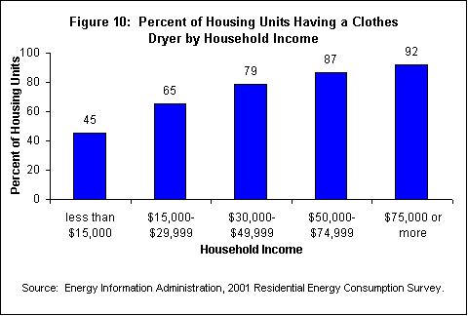

http://www.eia.doe.gov/emeu/recs/appliances/appliances.html
45, 65, 79, 87, 92, mean = 73.6%
- where only 45% of households own a tumble dryer, compared with 79% in the US
Other countrys dryer ownership
http://www.bbc.co.uk/news/magazine-11417677
UK only 45% of households own a tumble dryer
http://www.bbc.co.uk/news/magazine-11417677
Italy only 4% of households have a tumble dryer
http://www.allvoices.com/contributed-news/6973028-clothes-lines-versus-electric-tumble-dryers
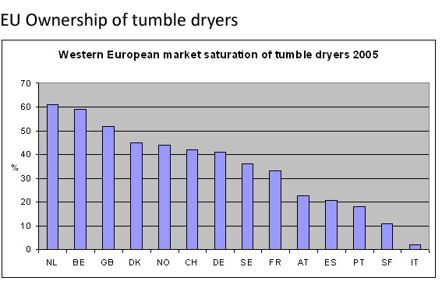

The carbon output for an average tumble dryer
An average tumble dryer runs at over 3.5 kWh per cycle
Using our grid electricity carbon conversion factor of 0.545 kg CO2 emitted per kWh
The carbon output for one cycle is:
  - x 0.545 = 1.90 kg CO2 per cycle.
http://www.dothegreenthing.com/wiki/display/WIKI/Don't+Use+a+Tumble+Dryer
How many Kg and tones of Co2 are created every year by tumble drying in the U.S?

On the avarage 300 cycles a year

U.S Housing units, 2009, 129,969,653

http://quickfacts.census.gov/qfd/states/00000.html
$1.90×300=570 Kg of co$² per house hold a year

129,969,653$×0.75=$ 97,477,240 (households that use tumble dryers)

$97,477,240 ×570=55,562,026,657 Kg of co$² a year

The U.K?

On the avarage 300 cycles a year

UK Households, 2004 estimate, 25,000,000
http://www.statistics.gov.uk/hub/index.html
$1.90×300=570 Kg of co$² per house hold a year

25,000,000 $×0.45=$ 11,250,000 (households that use tumble dryers)

$11,250,000 ×570=6,412,500,000 Kg of co$² a year

$6,412,500$ tones$of co$² a year
Running a tumble drier, £36 a year - Scottish and Southern Energy
= £405,000,000

$Italy$?

On the avarage 300 cycles a year

Italys Households, 2005 estimate, 23,300,000
http://www.istat.it/dati/catalogo/20050912_01/testointegrale.pdf
$1.90×300=570 Kg of co$² per house hold a year

23,300,000 $×0.04=$ 11,250,000 (households that use tumble dryers)

$11,250,000 ×570=,932,000 Kg of co$² a year

$932 tones of co2 a year$

$Netherlands$?

On the avarage 300 cycles a year

Dutch Households, 2002 estimate, 6,940,000
http://www.mnp.nl/mnc/i-en-0001.html
$1.90×300=570 Kg of co$² per house hold a year

6,940,000 $×0.62=$ 4,302,800 (households that use tumble dryers)

$4,302,800×570=2,452,596^{'},000 Kg of co$² a year

$2,452,596$ tones$of co$² a year

EU?

Taken across the EU and assuming 40% ownership (low estimate in a growing market) the resulting figure for the EU 15 (excluding less developed partners) is ... 74.6 million tonnes of CO2

http://www.rotaire.com/environmental-case.htm
U.S = $55,562,027$ tones$of co$² a year
U.K = $6,412,500$ tones$of co$² a year
ITALY = $932 tones of co2 a year$
NL = $2,452,596$ tones$of co$² a year
EU = 74,600,000 tones$of co$² a year

